ED STUFF

String formatting

.format()

* Always used after the last ‘’
* Formats the string into the type of variable needed
* x = water Eg. print(“I need this {}”.format(x))
* formatting floating points – {:.xf} x = amount of decimal

if statements

if x == 0:

print(“…”)

elif x == 1:

print(“…”)

else:

…

BOOLEAN statements

True/ False

True = 1

False = 0

**List**

x = [“apple”, “hey”, “oranges”]

print(“, ”.join(x)

output=apple, hey, oranges

.append() = adds string at the end of list

.max()

.min()

.join structure = “separator”.join(list)

String.split(separator)

n = list(map(int, num.split())) # puts list of numbers into integers while seperating them by spaces into a list of integers

**For structure**

For (new variable) in (existing array or list)

**Range structure**

range(end): end value is specified. By default, range() will start at 0, and count up in steps of 1 to the end value, but does not include the end value.

dictionarie keys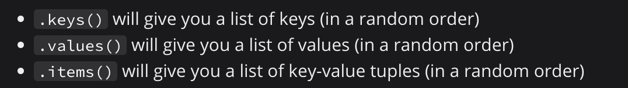

for i in n:

if i % 2 == 0:

count += 1

count = sum(1 for i in n if i % 2 == 0)